

SCHOOL OF ADVANCED TECHNOLOGY

ICT - Applications & Programming

Computer Engineering Technology – Computing Science



A31
Game C/S Model – Collaboration Diagram

Team:
[Student Name] - Id: [Student Id]

Quantum Millionaire networking Proposal

This template is suggested (not mandatory) to answer A5 Specification.

Part  1 | C/S Architecture

For this assignment, sections 1.1 and 1.2 are required. Completing the rest may earn you a bonus

Networking Messages
What messages are required? What format are your network messages?
Message Format | Description
Message Type | short text codes like JOIN, START, QUESTION, ETC…
Separator | , (comma separator)

Message | JOIN
Content format | 0,JOIN,PlayerName
Description/purpose | Client sends name to server to join the game
- Players will send their ID to the server. Here We used zero as an example.
Message | ASSIGN_ID
Content format | 0,ASSIGN_ID,PlayerID
Description/purpose | Server assigns ID to client
- ZERO (0) is the player ID who is hosting the game. Zero used as an example.
Message | START
Content format | 0,START
Description/purpose | Starts the game when enough players join

Message | QUESTION
Content format | 0,QUESTION,QuestionText;OptionA;OptionB;OptionC;OptionD
Description/purpose | Sends question and options to all players

Message | ANSWER
Content format | PlayerID,ANSWER,OptionNumber
Description/purpose | Player sends selected answer

Message | RESULT
Content format | 0,RESULT,PlayerID;Correct/Incorrect;Score
Description/purpose | Sends result and updated score

Message | CHAT
Content format | PlayerID,CHAT,MessageText
Description/purpose | Sends chat message to all players
- One player will send chat to the host (server), then the Host will update the UI. Then, everyone can see the chat on the UI text area (JTextArea).
Message | DISCONNECT
Content format | PlayerID,DISCONNECT,
Description/purpose | Client leaves the game

Message | SHUTDOWN
Content format | 0,SHUTDOWN
Description/purpose | Server notifies all clients that it is shutting down

Message | SPECTATOR
Content format | PlayerID,SPECTATOR,Watching
Description/purpose | Indicates that the player is no longer actively playing but can still watch scores and chat messages
- Spectator can see the questions and right answers, and the updated scores of the other players.

- ; is used inside the data field for multiple values
- Server messages use ID = 0

Updated UI Sketch
How will your UI change to manage the new requirements? For each question, provide a sketch of the UI, or a screenshot with modifications. Artistic style is not part of the mark, but clarity is.
- My UI is going to add the network functionality in the setting mode. There will be three buttons Host, connect and disconnect to play the game on the network. The chat and the score will be on the main screen where the player is selecting the options and continues playing the game.

How will a player select network modes?

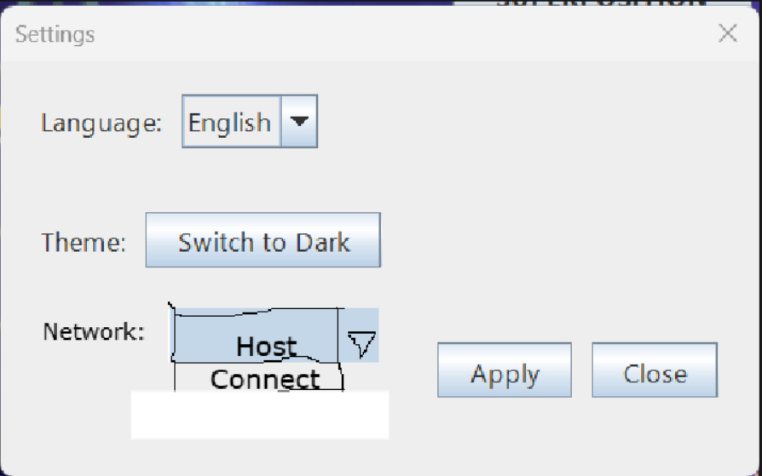

- A player selects network mode using the Network menu. They can choose Host to start a game or Connect to join an existing game by entering the IP address and port. They can also select Disconnect to leave the game.

How will a player configure the host? Will any assumptions be made (player name, etc?)
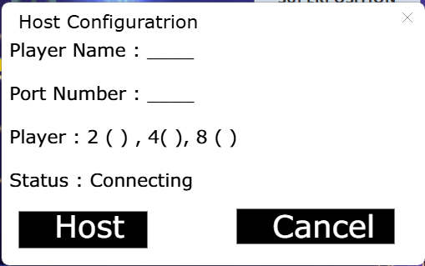

- A player configures the host by selecting Host from the Network menu and entering their name, port number, and number of players. After that, they click Host to start the server and wait for others to connect.

How will a player configure connecting as a client? Will any assumptions be made (player name, etc?)

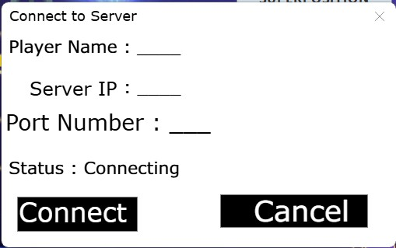
- A player configures connecting as a client by selecting Connect from the Network menu and entering their name, server IP address, and port number, then clicking Connect to join the game.

How will multiplayer look? How will you modify the score display (will it be another window, or will the current display change?) How about multiplayer chat?

- Multiplayer will show all players on the screen, not just one. The score display will be updated to show all players’ scores in the same window. A chat panel will also be added where players can send and see messages during the game.
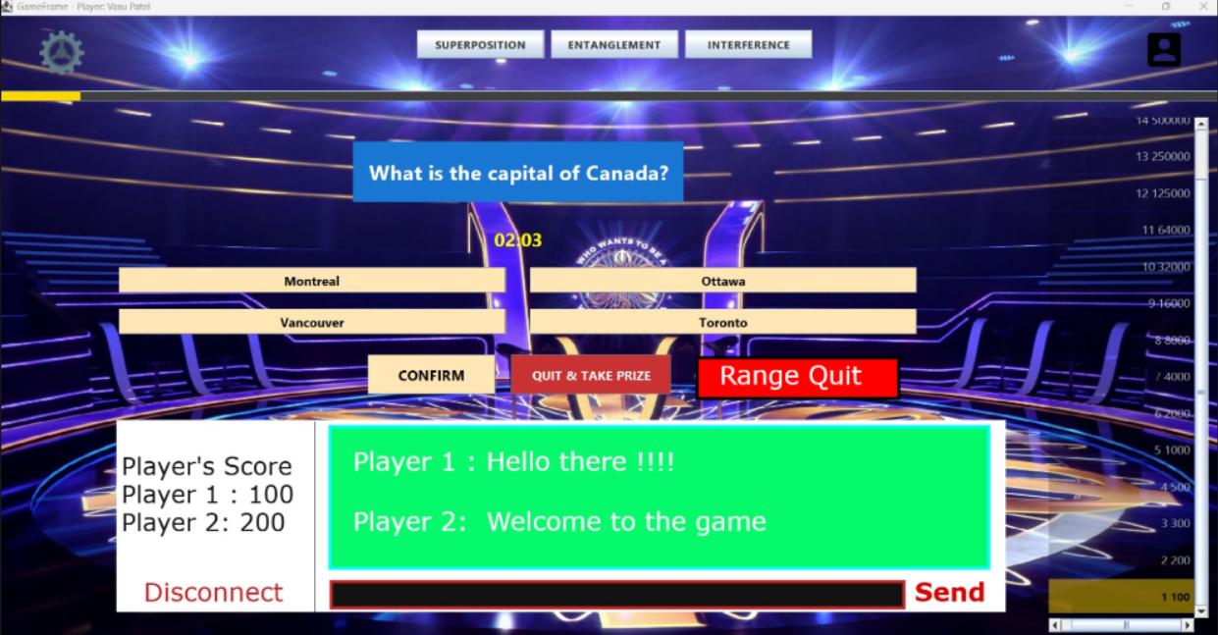

EXTRA: Updated UML

EXTRA: Updated Translation Tables

EXTRA: Anything else you think needs to be changed.

References
[Include eventual references used here]

Algonquin College
Winter 2026

